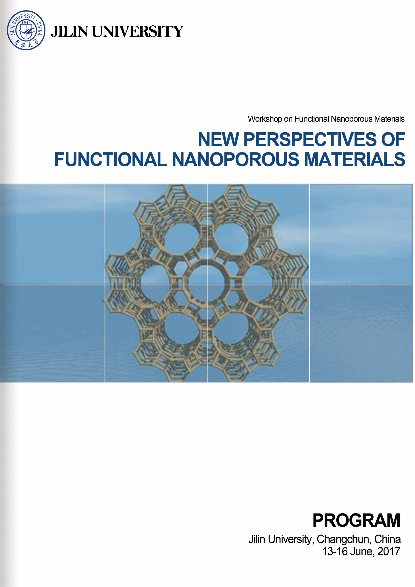

**WORKSHOP PROGRAM**

**Wednesday, 14 June, 2017, Lecture Hall (II), Auditorium**

|  |  |  |  |
| --- | --- | --- | --- |
| Time | Speaker | Title | Chairperson |
| 08:30 - 08:40 | **Opening Ceremony Jihong Yu** | | |
| 08:40 - 09:15 | **Stefan Kaskel** | **New Metal-Organic Frameworks with Ultrahigh Porosity, Switchability and Functionality** | **Guangshe Li** |
| 09:15 - 09:50 | **Fabrizio Cavani** | **Mixed Metal Oxides for Gas-phase Reactions: Bio-alcohols and Polyols Transformation to Added Value Chemicals** |
| 09:50 - 10:20 | **Coffee Break** | | |
| 10:20 - 10:55 | **Gopinathan Sankar** | **On the Formation of Zeolites through in situ and ex situ X-ray Techniques** | **Jean-Pierre Gilson** |
| 10:55 - 11:30 | **Peng Zhang** | **X-ray Spectroscopy of Some Metal Nanostructures** |
| 11:30 - 11:50 | **Group Photo** | | |
| 12:00 | **Lunch** | | |
| 13:30 - 14:05 | **Fei Wei** | **Hierarchical Zeolite Structures and Their Application on Methanol to Propylene and Aromatics** | **Sheng Dai** |
| 14:05 - 14:40 | **Jean-Pierre Gilson** | **Designer Zeolites: Better, Smaller, More Accessible and… Cheap** |
| 14:40 - 15:10 | **Coffee Break** | | |
| 15:10 - 15:45 | **Bao-Lian Su** | **Natural Law of Hierarchizing Holds Key to Enhancing Photocatalysis, Amplifying Gas Sensing and Extending Battery Life** | **Gopinathan Sankar** |
| 15:45 – 16:20 | **Jihong Yu** | **Zeolitic Materials: Prediction, Synthesis and Application** |
| 16:20 | **Laboratory and Campus Tour** | | |
| 18:00 | **Dinner** | | |

**Thursday, 15 June, 2017, Lecture Hall (II), Auditorium**

|  |  |  |  |
| --- | --- | --- | --- |
| Time | Speaker | Topic | Chairperson |
| 08:50 - 09:25 | **Sheng Dai** | **Porous Ionic Liquids: Challenges and Opportunities** | **Justin D. Holmes** |
| 09:25 – 10:00 | **Guangshan Zhu** | **Targeted Synthesis of Porous Aromatic Frameworks: From Structure Design to Advanced Application** |
| 10:00 - 10:30 | **Coffee Break** | | |
| 10:30 - 11:05 | **Lixin Wu** | **Supramolecular Self-Assembly of Inorganic Clusters for Soft Frameworks** | **Bao-Lian Su** |
| 11:05 - 11:40 | **Justin D. Holmes** | **Nanoparticle Promoters in Organic and Inorganic Reactions** |
| 12:00 | **Lunch** | | |
| 13:30 - 14:05 | **Xiulian Pan** | **Porous Materials and Selectivity Control in Syngas Conversion** | **Guangshan Zhu** |
| 14:05 - 14:40 | **Ben Slater** | **Computational Modelling Signposts New Directions in Porous Materials** |
| 14:40 - 15:15 | **Sanliang Ling** | **Computational Studies of Metal-Organic Frameworks: Defects, Electronic Properties and Gas Adsorptions** |
| 15:15 - 15:25 | **Closing Remarks Jihong Yu** | | |
| 15:25 | **Coffee and Free Discussion with Faculties and Students** | | |
| 18:00 | **Dinner** | | |

